Chapter 19, Problem 57.

Given the transmission parameters

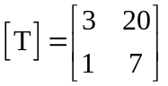

obtain the other five two-port parameters.

